(Approx. 2067 words)

Rooting and Custom ROM Installation of Kindle Fire HD 2nd Edition
By Bob Woods, Webmaster, Under the Computer Hood UG, CA
February 2017 issue, Drive Light
www.uchug.org
webmaster (at) uchug.org

We like to have a radio tuned to a talk radio station or music station during the day. Our location is in a town in a valley surrounded by mountains so our radio reception is poor. As a solution, we have been using a couple of older Kindle Fire HD 2nd generation tablets streaming our favorite stations via iHeart radio. Recently, one of the Kindles started having connectivity issues and was replaced with one of the newer $50 Kindle Fire HD tablets. Since the problematic unit was not being used for anything I decided I would try replacing the Amazon tweaked version of Android with a standard version. I wasn't worried about ending up with a brick as the unit is four years old so not in warranty and was no longer in use anyway.

The files listed and the following steps are intended for the Kindle Fire HD 2nd edition. They will not work on other manufacturers devices or even different models from the same manufacturer. The steps will be pretty much the same, but you will have to conduct an internet search with your models OS version to get the correct files and any step differences for your device. There are no guarantees that you will not experience any issues. That being said, lets jump into the thick of it.

First, I set the Kindle back to factory defaults. Since I will be replacing the Amazon OS with a standard version of Android I not register the unit. I also logged onto my Amazon account and de-registered the device. Next, onto the internet with multiple Google sessions looking up what was needed.

The first thing I found was the unit needed to be Rooted. This is to allow root access rights to the operating system. On units with proprietary operating systems, like the Kindle or phones tied to a particular service provider, root access is blocked by their version of the operating system. Rooting the unit is done via a root kit, which is an app that has been created specifically to give root access to a specific version of the installed operating system. This required using the Kindles settings setup to obtain its version of the operating system. Then do a Google search to look for the root kit. In my case the search term was "Root Kindle Fire HD OS 7.5.1". What I found was a YouTube video from Tekify with step by step instructions and links to the required software. It also had a link to written instructions.

There are two methods for installation. One with a PC to download, save and run files to do the actual root to the Kindle via USB. And one without a PC where you use the Kindle's browser to download, save and run the files directly. Since I was having Wi-Fi connectivity issues with the Kindle I opted for the method with the PC.

Following the video instructions:

- On your device go into settings (Swipe down from the top and press more) then scroll to “Security”. Set enable ADB to on and press ‘Ok’ on the warning. Go home on your device, make sure your kindle is NOT connected to the computer yet.
- Download the Tekify – Root Kindle Fire HD .zip file on to your computer and extract it.
- In the extracted folder, you will find another folder and a file named “KindleDrivers”, double click this file and press install, when another window pops up press next and wait for the install to complete, once it is done you can click finish and close out the remaining window. Your computer is now ready to use ADB and Fastboot.

- Once again in the extracted folder open the folder named “Root_with_Restore_by_Bin4ry_v33”. inside is a number of items. Double click “RunMe” (not the .sh file) and a command prompt will open.

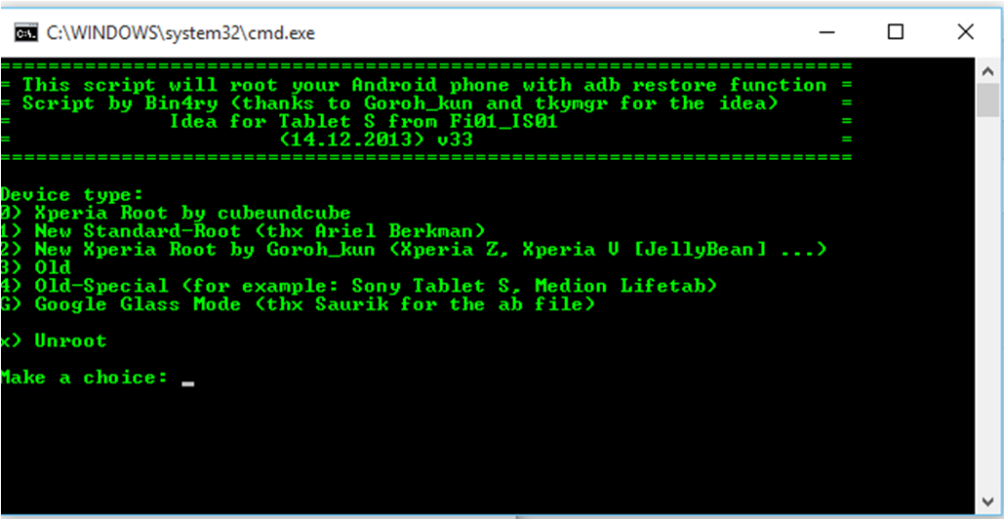

- Plug your Kindle into the computer with a USB cable and press 3 on your keyboard followed by enter.
- After a bit of script has run a message asking you to restore your data will appear on your Kindle, click “Restore my data”, don’t worry this will do nothing.
- 10 Seconds later your device will reboot. Once it has booted up the lockscreen will be black and your device will be slow, this is normal.
- Once your computer recognizes the device again some more script will run and the window will close. Your device will also reboot one last time.
- When your device is booted up you will have Root as well as an app called SuperUser installed.

At this point the Kindle is Rooted. However, the Amazon OS is still on the Kindle. To replace it would require two things:

- A backup and recovery application that sets outside of the OS and can be called up at bootup. Think of this as the equivalent of using the function key to get to a Boot Menu on a PC to boot from a USB or DVD drive. This is the only way to be able to replace the OS as Android devices always boot directly to the OS.
- A custom ROM to replace the Amazon Kindle OS. In the Android world a ROM is not a physical device, Read Only Memory. It is a software package of a version of Android custom configured to be compatible with your hardware. It will be close to stock Android, but usually has some additional features. I found there are different custom ROM builds, each with slightly different extra features over plain vanilla Android. The choice is up to you.

For the backup/recovery program I installed an open source program called TWRP (Team Win Recovery Program). For the ROM I settled on Omni 5.1 which is Android Lollipop 5.1.1. I could have gone with Android Marshmallow 6.1 from Cyanogen, but the Kindle ROM version was an unofficial beta version (CyanogenMod 13).

The instructions for installation of TWRP are at Tekify at http://www.tekify.co.uk/kindle-fire-hd/recovery/. Not wanting to use the Kindle WiFi I again downloaded the three files listed below from the URL links in the instructions and transferred them to the Kindle download folder via USB. These would then be run directly on the kindle. The below instructions are shown in the YouTube video, but since it is easy to brick the Kindle during this process, I wanted to follow the written instructions (also listed) after watching the video.

- On the Kindle, enable Installation of Applications from Unknown Sources. (Settings > Device > Allow Installation of Applications).
- Download the three files onto your device: FireFlash.apk, KFHD7 Freedom Boot.img and either KFHD7 TWRP 2.7.0.0.img or KFHD7 TWRP 2.8.3.0.img (It doesn’t matter which one however 2.8.3.0 is obviously the latest version). As before, I downloaded the three files onto my PC and transferred them to the Kindle via USB.
- The rest of the steps for TWRP are then done on the Kindle.
- Install FireFlash.apk and open it up.
  - Grant the app Root Access if necessary.
  - Under the ‘Bootloader’ heading tick the ‘Flash kfhd7-u-boot-prod-7.2.3.bin’. This is required or your device will be bricked.
  - Under ‘Boot Partition’ click ‘Not Flashed’ and find where you downloaded the files.
  - Select ‘kfhd7-freedom-boot-7.4.6.img’ (This is the correct one even though we are on a later version).
  - Still under the ‘Boot Partition’ heading tick ‘Apply Stack Override’.
  - Under the heading ‘Recovery Partition’ once again click ‘Not Flashed’.
  - This time select the other file (‘kfhd7-twrp-2.7.0.0-recovery.img’ the number will be different depending which version of TWRP you downloaded).
  - Make sure to tick ‘Disable Recovery Auto Update’ .
  - Now at the bottom under the heading ‘Execute’ press ‘Flash, Install Script’
  - Once this has finished (DO NOT CANCEL IT) tap ‘Reboot Into Recovery’ and wait for your device to boot into TWRP.

- I would strongly recommend making a backup once in TWRP.
- Finally, you can boot into TWRP any time from a powered off state by pressing the ‘Power Button’ as normal and then holding just the volume up button until you enter recovery.

Now for the ROM.
Omni 5.1 is a ROM is based on CM12 (Cyanogen Mod 12) however is modified to suit the Kindle Fire HD. Make sure you have at least 70% battery. As a quick warning do not try to overclock the CPU on this ROM as it will cause your device to totally freeze up after a couple of minutes of use. Once again, the instructions are on Tekify at https://www.youtube.com/watch?v=_c5hHSCO_o8 .
- Download the Omni 5.1 ROM, Gapps for 5.0 and Update SuperSU onto your device. once again, I downloaded to my PC and transferred to the Kindle via USB.
- The rest of the instructions are done on the Kindle.
- Reboot into the TWRP Backup/Recovery app.
  - This is done by first, completely shutting down the Kindle (push and hold the power until you get the shutdown button and touch it).
  - Then push the power button to boot up. When the Kindle Fire logo shows, push and hold the left volume button (volume up) until the word Fire turns blue and let go of the volume up button after a second or two.
  - The Kindle will open in the TWRP application. The TRWP home screen looks like the following image. The video shows the other screens in TWRP you will be dealing with.

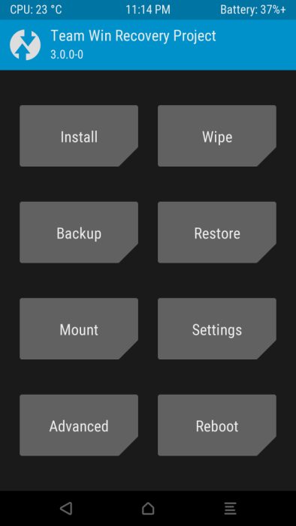

- Make a backup using the default settings just in case something goes wrong and you need to restore to a previous state.
- After the backup, click ‘Wipe’ and swipe to factory reset. This MUST be done or you will have problems later. This does not wipe your Internal Storage don’t worry.
- Then press ‘Install’ and navigate to the folder where you downloaded the Omni 5.1 ROM and tap it.
- Swipe to confirm flash, this will take a while DO NOT cancel.
- After it is done DON’T press reboot system or you will have no Google Apps and you will experience errors.
- Click ‘Home’ and then once again ‘Install’
- Select the ‘gapps 5.0′ file and once again wait. Once again go ‘Home’ otherwise you will not have root access.
- Click ‘Home’ and then ‘Install’ for the final time.
- Select Update SuperSU.zip and press reboot system once it is done flashing.
- First boot up may take a while. However, if it takes more than 10 minutes hold the power button till your device goes off and try turning it on again. From the video we learned that after a ROM replacement you can get into a boot loop, but it should resolve after one or two reboots.
- If it still won’t boot go back to TWRP recovery and restore your backup. This will restore your Kindle OS which was saved during the backup. Then check Tekify for hints on how to proceed.

I did not have any issues with any of the steps and all worked after the process was finished. So, what were the results? So far, the Wi-Fi connectivity issue I was having has not surfaced again, being solid. Could have been caused by a system glitch in the Kindle OS or botched update from Amazon. I can now install applications that previously required the device to be rooted. My efforts will not be over written by any updates Amazon is pushing out as the Kindle is no longer a registered device. If I wish I can try other ROM updates by just loading them through TWRP.

Rooting a device and installing a custom ROM is not for everyone. If something goes wrong during the Root or ROM process you stand the chance of turning your device into a brick, though there are recovery step instructions out on the internet. Rooting will void your manufacturer's warranty. Installing a custom ROM is not so much a necessity these days as Launchers are available to replace the stock home page launcher that came with your device, often with advantages over the built-in launcher. However, a launcher is just an app that runs on the stock OS that came with your device with all of the lockdown the manufacturer put into the OS. if you are looking for an updated Android version or to completely unlock your device look into Rooting and installing a custom ROM.

